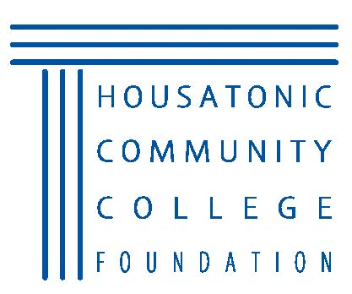
Housatonic Community College
2018 Distinguished Alumni Awards
CALL FOR NOMINATIONS
Background
For many, the pathway to personal and professional achievement included Housatonic Community College (“HCC”). HCC and the HCC Foundation, Inc. seek to recognize and honor alumni or community leaders who have achieved outstanding success in their careers and have made a positive impact on their communities.
Please take a moment to nominate an HCC alumnus or alumna whose commitment to excellence is a tribute to our fine academic standards. We will then contact each nominee and provide them with a more detailed application to fill out.
This year’s inductees will be recognized at our 9th Annual Alumni Award Gala on Saturday, April 21, 2018 at Housatonic Community College.

Criteria
Diversity of candidates is welcomed and encouraged. Please use the following eligibility criteria.
Distinguished Alumni Award
The Distinguished Alumni Award is presented to an alumni of Housatonic Community College for outstanding professional and/or personal achievements bringing credit to himself/herself and, in turn, credit to Housatonic Community College. To be eligible for this award, candidates must have attended Housatonic Community College for a minimum of 30 semester hours.

Young Alumni Award
The Young Alumni Award is presented to a graduate of Housatonic Community College in recognition of professional and/or personal achievement. The recipient shall be 40 years of age or younger.

Friend of the College
The Friend of the College Award may be presented to a non-graduate of the College who has provided distinguished leadership and/or service/support to Housatonic Community College. Friend may include an individual; organization; corporation; or member of Housatonic’s faculty or staff.

Community Service Award
The Community Service Award may be presented to a graduate or leader for extraordinary community service, and for the contributions that advance the improvement of society, thereby reflecting favorably on the College.

Past Alumni Hall of Fame Inductees:
2016 – Ben Ortiz, Robin Avant, Tiffany Teixeira, and Barbara & Carl Johnson
2015- Dawn Hatchett ‘93
2014- Jerry Vigorito
2013- Deloris Curtis, Leona May
2012- Linda Bayusik, Paul Piorek, Kevin Russo
2011- Patricia J. Foley, Fernando Goncalves Rosa, Nancy L. Sidoti
2010 - Janet L. Janczewski, Frances M. Newby, David Peck
2009- John L. Evanich, Charlene Labate Santoro, Mary Ann Vlahac

PLEASE PRINT
Please check for appropriate award:
___ Distinguished Alumni Award ___ Young Alumni Award

___ Friend of the College ___ Community Service Award

NOMINEE INFORMATION
Note: One form is required for each candidate you nominate.

I wish to nominate: __________________________ Year attended (if known): ______________
Affiliation: ____________________________________________________________________
Address: ______________________________________________________________________
Daytime Telephone: _____________________ Evening Telephone: ______________________
E-mail: _______________________________________________________________________
Would you prefer this nomination to be anonymous: Y N
Brief Description of nominee’s achievement (s):_______________________________________ ________________________________________________________________________________________________________________________________________________________________________________________________________________________________________________________________________________________________________________________
(Each nominee will be asked to complete an application form.)
YOUR INFORMATION
Name: ____________________________________ Title: ______________________________
Affiliation: ____________________________________________________________________
Address: ______________________________________________________________________
City/State/Zip: _________________________________________________________________
Daytime Telephone: _____________________ Evening Telephone: ______________________
E-mail: _______________________________________________________________________

Nomination must be received by February 16, 2018. You are not expected to provide comprehensive information; the nominee will be asked to submit a separate application detailing his or her accomplishments. All completed applications will be reviewed by our independent judging panel.
Additional forms may be downloaded from our website at www.hcc.commnet.edu/hccf/
Please e-mail, or mail completed form:
HCC Foundation e-mail: Fiona Hodgson - Fhodgson@housatonic.commnet.edu
HCC Foundation Address: 900 Lafayette Boulevard, Bridgeport, CT 06604

